SSOM Faculty Promotion Packet Example
Academic Year 2026-2027
HSC Faculty Administration

- Cover Sheet Example – Page 2

- Statement on the use of AI – Page 3
- Section 1: Department Letters – Page 3
  - Chair Letter Example
  - Promotion Committee Example
- Section 2: Candidate Curriculum Vitae – Page 6
- Section 3: Candidate Personal Statement – Page 7
- Section 4: Teaching Evaluations – Page 8
  - Medical Student Evaluation Example
  - Resident/Fellow Evaluation Example
- Section 5: Letters of Evaluation/Recommendation Requirements – Page 11
  - ACRT Track
  - AET Track
  - ART Track
  - AST Track
  - CET Track
  - RT Track


  - Letter of Recommendation Example – Page 13

Promotion and Tenure Cover Sheet 2026-2027

Candidate: __________________________________
(First) (M.) (Last) (Credentials)

Primary Department: _______________________________________
Secondary Department(s), if applicable: ______________________________________
Present Faculty Status: Full-time or Part-time
Date of Initial Appointment at Loyola University: ___________________
Present Rank: ___________________________ Initial Date of Current Rank: _________________
Number of Years at Current Rank: ______________________
Is this an early promotion (less than 5 years in rank) ____________________
- If the number of years at the current rank is less than 5 years as of July 1, 2026 (need to be in rank for 5 years since July 1, 2021 – July 1, 2026), this is considered an early promotion. This requires the department letters, the faculty’s CV and personal statement to contain detail on how the faculty member demonstrated extraordinary effort for consideration for early promotion.

Present Tenure Status: ☐ Tenure-Track ☐ Tenured ☐ Non-Tenure-Track
Present Academic Track: ☐ AET ☐ ART ☐ AST ☐ ACRT ☐ CET ☐ Research Track
Candidate Seeks:
☐ | Promotion, to be effective July 1, 2027 to the rank of:
 | ☐ | Professor
 | ☐ | Associate Professor
 | ☐ | Rank of (Other): ___________________________  ☐ Clinical Professor (if Part-Time)  ☐ Clinical Associate Professor (if Part-Time)
☐ | Tenure, with promotion (above), to be effective July 1, 2027
☐ | Tenure only, to be effective July 1, 2027

Statement on the use of AI
The SSOM CART strongly recommends against using any AI tools in the composition of promotion materials. Our experience has shown that AI tools can introduce major factual errors that can undermine the integrity of a candidate’s application. Regardless of how a candidate’s promotion materials are composed and compiled, department chairs are ultimately responsible for any significant factual inaccuracies submitted under their signature. Intentional or negligent misrepresentation of the qualifications of a candidate, no matter how introduced, is a very serious matter, and may constitute fraud.

Section 1: Letter(s) from Department:
- Chair Letter (Mandatory for all submissions)
- If the faculty has a secondary/joint appointment, that chair of this department needs to provide a letter.

The following categories are only for those departments that utilize this set-up for promotions:
- Division Director Letter (Department of Medicine)
- Department Promotion Committee Letter

Not all departments will have a division director letter or a department promotion committee letter. However, all packets must include the Chair letter.

Departments that have an internal promotion committee (please confirm with your chair whether or not your department has an internal promotion committee):
- Bioethics
- Emergency Medicine
- Family Medicine
- Medicine – Department of Medicine
- Neurology
- OB/GYN
- Pathology
- Pediatrics
- Psychiatry
- Radiology
- Surgery

*Please note that a department promotion committee member cannot also author one of the candidate’s letter of evaluation/recommendation.

Department Letter Examples follow on next page:

Example of a Chair, Secondary/Joint Chair or Division Director Letter
*If the candidate has a joint appointment, a separate letter is needed from Secondary Department Chair.
*A separate letter from the Division Director is needed for Department of Medicine faculty only.
On Letterhead
Date (Must be dated within past 6 months)

To: Sam J. Marzo, MD
Dean and Chief Diversity Officer, Stritch School of Medicine

Re: Candidates Name, MD

Dear Dr. Marzo:

I write in support of the promotion of (Faculty Name) to the rank of (Associate Professor/ Professor) on the (Name of Track, i.e., ACRT, AET, ART, CET or RT) (if seeking tenure, put that THE detail here).

Dr. Candidate was recruited to Loyola in (YEAR). PROVIDE A DISCUSSION OF PAST EXPERIENCE, DETAIL ON TRAINING, I.E., DOCTORAL DEGREE, MEDICAL SCHOOL/RESIDENCY, FELLOWSHIP, ETC AND ANYTHING THAT STANDS OUT FROM THIS TIME. IF A PHYSICIAN, THEIR BOARD STATUS.

SPECIFIC DOCUMENTATION ON THE CANDIDATE PERFORMANCE FROM CRITEREA LISTED IN THE ACADEMIC GUIDELINES BASED ON THEIR ACADEMIC TRACK.
The following are examples of what to include based on the faculty’s track, not all are applicable to every candidate:

- Administrative duties or participation on committees at the SSOM: Hospital or university level, and offices held within the department, involvement in the recruiting process of residents and medical students will be considered as intramural service.
- Teaching excellence: Courses and lectures provided to medical students, residents, fellows, graduate students, etc., student counseling, student mentoring, tutoring and day-to-day teaching activities, and academic teaching rounds.
- Administrative roles and teaching outside the medical center: Extramural assignments such as invited presentations, selection to review panels, presentations at societal meetings, committee work on international, national or regional societies, performing manuscript reviews for journals, and being involved in legislative activities, i.e. state societies or regional activities, may also be considered.
- Demonstrated Scholarly Activity/Grant Funding. Publication of scholarly works, adoption of educational material in print or other media, syllabi, curricula, web-based training modules or courses, and/or technologies (e.g., simulation); development of educational methods, policy statements, and/or assessment tools; and/or popular dissemination of teaching expertise (e.g., blogs, webinars, Twitter Chats, etc.). Grant Funding – Current or grant funding within time at current rank.
- Clinical Activity: The candidate should have a sustained level of performance and reputation for clinical excellence at the SSOM and other service components of the LUHS.

For Early Promotions: If this is an early promotion, acknowledgement of it being an early promotion and documentation of the extraordinary efforts the candidate has demonstrated during their tenure at LUC that supports the honor of early promotion.

Closing: I support the promotion of Dr. CANDIDATE to the rank of Associate Professor/PROFESSOR with utmost enthusiasm. SUMMARY OF WHY THEY SUPPORT THIS PROMOTION.

Sincerely,
Original signature

Chair/Division Director Name, Title and Department

Example Department Committee Summary

Report of the Department of SPECIALITY - Promotion Review Committee

CANDIDATE: ___________________________________________

DATE OF REVIEW: ___________________________________________

Following is a summary of the recommendation of the faculty review committee for Dr. CANDIDATE for promotion to the rank of Associate Professor/PROFESSOR in the Department of Name. We have reviewed Dr. CANDIDATE’S CV and the promotion criteria for this proposed rank and academic track. Our recommendation is based upon Dr. CANDIDATE’S teaching, research productivity, clinical program, national and international reputation and the service to the Department of SPECIALTY, the Stritch School of Medicine and Loyola University of Chicago.

Following is a summary of our findings (suggested topics):

- Time in Rank: 5 years:
- Clinical Care Recognition:
- Peer Reviewed Published Research:
- External Funding:
- Other:
- Teaching and Service Recognition:
- Honors/ Awards:
- National and International Reputation:
- Editorial Contributor:
- For Early Promotion – Acknowledgement that it is an early promotion and supporting criteria

Final recommendations of their findings and recommendation of promotion, including the vote count.

Members of the committee names.

Original Signature

Committee Chair Name

Section 2: Candidate Curriculum Vitae
Following is the suggested format for the CV. A different style can be submitted, but must contain all of the requested information. A more detailed example is at: https://ssom.luc.edu/cart/
Curriculum Vitae Format Example
General Information
Date Prepared: Must have a current date
Name: Full name, Degree
Office Address
Home Address
Work e-mail:
Education:
Full name of all higher educational institutions attended, included postdoctoral training, internships, residencies, clinical and research fellowships
Month/Years attended
For graduate degrees, note field or discipline.
For the next categories, please make sure to include name of academic institution, title and month/years (list only those positions that are related to your professional field)
- Academic Appointments
- Hospital or Affiliated Institution Appointments
- Other Professional Positions and Major Visiting Appointments
- Hospital and Health Care Organization Service Responsibilities and Major Administrative Responsibilities
- Major Committee Assignments
- Professional Societies and Society Role (e.g., member, officer, committee assignment)
- Community Service Related to Professional Work
- Editorial Boards
- Awards and Honors
PART II: Scholarly Activities, Research, Teaching and Clinical Contributions
- Grants – Detailed information required – dates, role, funding information, title, brief description of research;
- Current Research: Activities other than those mentioned above (bench research, clinical trials, outcome studies, efficacy studies as applicable) – same detailed information required;
- Report of Teaching: Local contributions, graduate medical course, local invited teaching presentations, e.g., seminars, grand rounds, continuing medical education course, advisory and supervisory responsibilities in clinical or laboratory setting (for medical or graduate students, resident or fellows), teaching leadership role in department/affiliated Institution/Medical School;
- Names of Advisees or Trainees: Years in position under your supervision, and current position. List only those trainees on whose careers you have made a significant impact;
- Invited Presentations (e.g., visiting professorship, invited lecture, plenary presentation, seminar);
- Professional and Educational Leadership Roles: e.g., program chair for professional society annual meeting or member of steering committees;
- Administrative Responsibilities at home institution and beyond LUC;
- Description of teaching award(s) received;
- Major curriculum offerings, teaching cases or innovative educational programs developed;
- Report of Clinical Activities.

Part III: Bibliography
Number references consecutively in order in which they were published (oldest first). Please add PMID.
Instructions to look up PubMed ID (PMID)
Typically, only articles from peer-reviewed journals are in PubMed. Association magazines, dissertations, book chapters, books, and conference proceedings are not typically included in PubMed. Here's the URL to look up the PMID: https://pubmed.ncbi.nlm.nih.gov/?otool=luclib
PubMed's search box is typically sufficiently sensitive to be able to locate citations by title. If an article citation doesn't appear after a title search, it's probably not in PubMed and therefore will not have PMID. If the faculty member is concerned, they can reach out to the Health Sciences Library at hsl@luc.edu for assistance.
Section 3: Candidate’s Personal Statement
- Must be in the form of a narrative; not an outline.
- The narrative provides detail that supports the candidate meeting all of the criteria listed on their academic track guidelines to support a promotion.
- It is recommended that a candidate’s personal statement be 2 - 3 pages in length. A lengthier personal statement is recommended for faculty going up for early promotion.

Example Personal Statement

DATE
Personal Statement for NAME, MD

It is an honor to be proposed for promotion to RANK of SPECIALITY at Loyola University Medical Center. FOLLOWING IS AN OVERVIEW OF MY CONTRIBUTIONS TO MY DEPARTMENT AND LOYOLA UNIVERSITY CHICAGO DURING MY TENURE AT LUC:

SPECIFIC DOCUMENTATION ON THE CANDIDATE PERFORMANCE FROM CRITEREA LISTED IN THE ACADEMIC GUIDELINES BASED ON THEIR ACADEMIC TRACK. The following is for the CET Track:
- Clinical Activity: The candidate should have a sustained level of performance and reputation for clinical excellence at the SSOM and other service components of the LUHS.

- Administrative duties or participation on committees at the SSOM: Hospital or university level, and offices held within the department, involvement in the recruiting process of residents and medical students will be considered as intramural service.

- Teaching excellence: Courses and lectures provided to medical students, residents, fellows, graduate students, etc., student counseling, student mentoring, tutoring and day-to-day teaching activities, and academic teaching rounds.

- Administrative roles and teaching outside the medical center: Extramural assignments such as invited presentations, selection to review panels, presentations at societal meetings, committee work on international, national or regional societies, performing manuscript reviews for journals, and being involved in legislative activities, i.e. state societies or regional activities, may also be considered.

- Demonstrated Scholarly Activity: Publication of scholarly works, adoption of educational material in print or other media, syllabi, curricula, web-based training modules or courses, and/or technologies (e.g., simulation); development of educational methods, policy statements, and/or assessment tools; and/or popular dissemination of teaching expertise (e.g., blogs, webinars, Twitter Chats, etc.).

- Grant Funding – Current or grant funding within time at current rank.
For Early Promotions: If this is an early promotion, acknowledgement of it being an early promotion and Documentation of the extraordinary efforts the candidate has demonstrated during their tenure at LUC that supports the honor of early promotion.

Closing Remarks: Summary of their accomplishments, etc.

Original Signature

CANDIDATES NAME

Section 4: Teaching Evaluations
- Required for all years at current rank, separated by academic year;
- Must be Anonymous Evaluations;
- Unique to the Candidate – does not include other instructors names;
- Optimally, the evaluations will be formatted to a yearly summary report for each academic year by each type of trainee group.
- Please remove any photos of the faculty going up for promotion.
- Evaluations are from the following LUC/SSOM categories of trainees:
  - Medical Student Evaluations – Ask your department’s SSOM Clerkship Coordinator. A medical student’s faculty specific comments and scores are automatically pulled into the faculty member’s FIS, annual summary, and in ranked order (highest scores first and color coded). These are listed annually and could be copied and pasted into a document for submission.
  - Graduate Student Evaluations – These are dependent upon the assigned department administering and collecting them. SSOM currently does not collect these in FIS. Some departments may request them, but they aren’t currently formally collected. For example, the department of Bioethics collects evaluations for their own graduate student teaching sessions. This said, I believe the University has an online course evaluation system but it isn't universally used by all graduate programs.
  - Resident Evaluations – Ask your department’s Residency Coordinator to run a report in New Innovations
  - Fellows Evaluations - Ask your department’s Residency Coordinator to run a report in New Innovations
  - Grand Rounds Evaluations - These ae collected by departments and part of the CME requirements for Grand Rounds. For assistance, please contact Mary Jurasas, Administrative Director of Continuing Medical Education (CME), at mjurasas@luc.edu.
  - Lecture Evaluations and Simulation Lab Evaluations - If lectures or simulation events incorporate SSOM students, they would be captured by SSOM and imported into FIS, but if resident activities, it would be dependent upon the department, GME typically captures these resident/fellow evaluations of teaching faculty. Some departments do collect evaluations on each presentation.

- If the faculty member has been at LUC for less than two years, teaching evaluations should be obtained from former institutions.
- Please note that teaching evaluations are required for all academic tracks.
- For CET track, teaching evaluations are mandatory as teaching is a major component of this academic track.

Evaluation Examples

- One evaluation summary report should be provided for each academic year the faculty has been teaching. For example, if the faculty taught residents every year since their last promotion, a total of five residency summary evaluation reports would be provided broken down by the following dates:
July 2020 to June 2021, July 2023 to June 2024,
July 2021 to June 2022, July 2024 to June 2025,
July 2022 to June 2023
- Both scores and comments from evaluators are needed.

Medical Student Evaluation Example: (Medical student evaluations can be obtained from your department’s SSOM Clerkship Coordinator)


One evaluation summary per academic year

Dr. Candidate’s Name
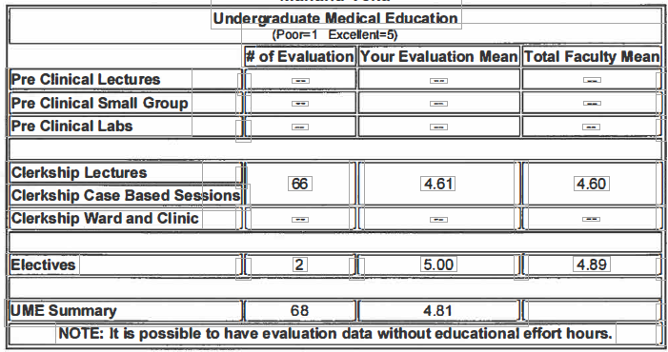

Medical Student Comments:
Please follow the case discussion for the next lecture you give.
Excellent! Enthusiastic and knowledgeable teacher. Challenged us to go beyond our automatic answer of protoco1 treatments
Phenomenal Teacher. He wanted to make sure that we actually understood the topic.
Very knowledgeable.

Resident/Fellowship Evaluation Summary Example: (obtained from department educational coordinators – report in New Innovations):

Department of Specialty
Residents Evaluations of Attending
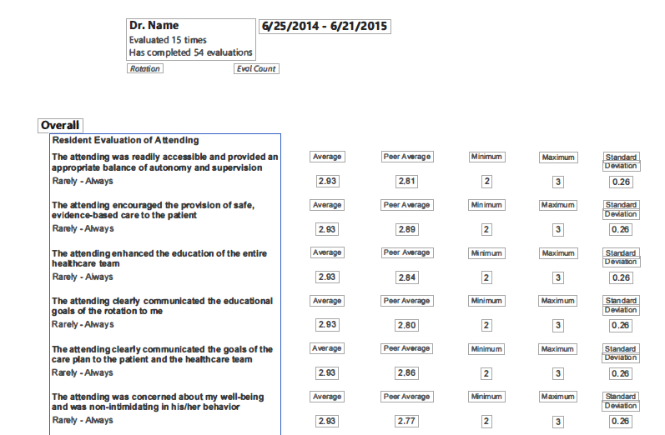
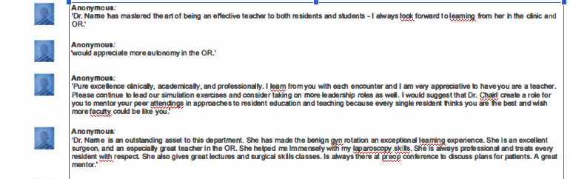

One evaluation summary per academic year

Dr. Candidate – 07/01/2015 – 06/30/2014

Section 5: Letters of Evaluation/Recommendation:
- Authors of letters must be active faculty (not Emeritus faculty) of the same rank the faculty is going up to for promotion or above the candidate’s proposed promotion rank. Letters from Emeritus faculty will not be accepted;
- Letters must be on letterhead;
- Author’s current rank and discipline/specialty referenced in letter or under signature;
- Letters are addressed to the department Chair;
- Letters are dated within 6 months of promotion packet submission;
- Author cannot be a former mentor or advisor;
The letter writer should state in their letter that they were not a former mentor, advisor or supervisor.
- Author must be an academician in the candidate’s discipline, specialty, or area of expertise;
- Author cannot be a department promotion committee member, unless they recuse themselves from their own internal department’s promotion committee’s deliberations. This will need to be noted in the letter of recommendation.
- Number of recommendation letters are based on academic track, as listed below.
- Please note, letters of recommendation should not simply repeat what is in the applicants CV, but rather highlight important accomplishments and put them into context.

CET Track
Promotion to Associate Professor
New Guidelines – CET Track -
4 letters total - Promotion to the Associate Professor level on the CET will require 1 external letter of recommendation/evaluation and 3 internal letters of evaluation. All letters must come from referees at the academic rank of associate professor or its equivalent in the candidate’s discipline or specialty area and must exclude letters from the candidate’s former mentors or advisors.

Promotion to Professor
New Guidelines – CET Track
4 letters total. Promotion to the professor level on the CET will require 3 external letters of recommendation/evaluation and 1 internal letter of recommendation/evaluation. All letters must come from referees at the academic rank of professor or its equivalent in the candidate’s discipline or specialty area and must exclude letters from the candidate’s former mentors or advisors.

ART Track
Promotion to Associate Professor with/without Tenure

New Guidelines – ART Track – Promotion to Associate Professor with Tenure
The department chair will obtain letters from at least 4 to 6 non-Loyola researchers, of whom at least four were not the primary mentors during the candidate’s training as a PhD student or post-doctoral fellow, or current collaborators. The letters will be from prominent individuals in the candidate’s field of expertise, who can assess the productivity, quality, and goals of the candidate’s research efforts. The chair will request that letter-writers provide a short CV, such as an NIH bio sketch. If not clarified in the recommendation letter, the chair will specify in their letter whether the recommender trained the candidate.

Promotion to Professor with/without Tenure

New Guidelines – ART Track
The department chair will obtain letters from at least 4 to 6 non-Loyola researchers, of whom at least four were not the primary mentors during the candidate’s training as PhD student or post-doctoral fellow, or current collaborators. The letters will be from prominent individuals in the candidate’s field of expertise, who can assess the productivity, quality, and goals of the candidate’s research efforts. The chair will request that letter-writers provide a short CV, such as an NIH bio sketch. If not clarified in the recommendation letter, the chair will specify in their letter whether the recommender trained the candidate.

AET Track
Promotion to Associate Professor without Tenure

New Guidelines – AET Track
2 letters of evaluation from non-Loyola faculty of appropriate rank;
1 letter of evaluation from a Loyola faculty of appropriate rank.

Promotion to Professor without Tenure

New Guidelines – AET Track
2 letters of evaluation from non-Loyola faculty of appropriate rank;
1 letter of evaluation from a Loyola faculty of appropriate rank.

AST Track
Promotion to Associate Professor with Tenure
New Guidelines – AST Track
2 letters of evaluation from non-Loyola faculty of appropriate rank;
1 letter of evaluation from a Loyola faculty of appropriate rank.

Promotion to Professor with Tenure
New Guidelines – AST Track
2 letters of evaluation from non-Loyola faculty of appropriate rank;
1 letter of evaluation from a Loyola faculty of appropriate rank.

ACRT Track
Promotion to Associate Professor with/without Tenure

New Guidelines – ACRT Track
2 letters from two non-Loyola academicians (other than prior mentors or advisors) in the candidate’s discipline or specialty area will be solicited. These letters should include an appraisal of the quality, contribution and goals of the candidate’s academic career. One or more additional letters will be obtained from outside or within the Loyola community. All letters must come from referees at the academic rank of associate professor or its equivalent and must exclude letters from the candidate’s former mentors or advisors.

Promotion to Professor with/without Tenure

New Guidelines – ACRT Track
In either the ACRT tenure or non-tenure track, promotion to professor and/or the granting of tenure will be evaluated using the same criteria as detailed for associate professor, with letters from non-Loyola researchers evaluating the national and international reputation of the candidate. Four letters of recommendation, three external, are required for promotion to full professor and must exclude letters from the candidate’s former mentors or advisors.

RT Track
Promotion to Associate Professor and Professor
Current and New Guidelines
4 to 5 letters non-Loyola Researchers with at least 4 not primary mentors during training or current collaborator.

Example Letter of Recommendation Physician’s Letterhead
Date (must be written within past 6 months)

Address Letter to:
Chairman of Department
Department Name
Loyola University Medical Center

Dear Dr. Chairman Name:

It is my pleasure to write this letter of recommendation for Dr. NAME for the appointment of _____________________________ in the Department of _____________.

- Please provide a summary of your professional qualifications as the letter writer.

- Applicant Information: A summary of the following qualifications, as applicable to the applicant, needs to be provided. Following are examples of what to address:

- Length of time you have known the letter writer.

- Known administrative activities or participation on committees either at local, regional, national or international organizations: professional supervision, participation in student and resident training-centered activities, extramural assignments such as invited presentations, selection to review panels, presentations at societal meetings, committee work on international, national or regional societies, performing manuscript reviews for journals, and being involved in legislative activities, i.e. state societies or regional activities.

- Teaching - Courses taught to trainees, lectures given, student counseling, student mentoring, tutoring and day-to-day teaching activities, and academic teaching rounds.

- Demonstrated Scholarly Activity - publication of scholarly work in peer-reviewed journals, or invited manuscripts, book chapters, review papers, abstracts given, exhibits presented at national organization meetings or invited manuscripts, development and local adoption of educational material in print or other media, syllabi, curricula, web-based training modules or courses, and/or technologies (e.g., simulation); development of educational methods, policy statements, and/or assessment tools’ publication of chapters and reviews within textbooks; development of educational material in print or other media with local.

- Grant Funding/Research – list any known grant funding or research of applicant.

- Clinical Activity - Any reputation for clinical excellence or other clinical service components.

I support the appointment of Dr. NAME with strong enthusiasm.

Sincerely,
Original Signature

Author Name and Credentials
Author Rank
Institution/Organization

